Sebastian Schwank
11.07.2017

MidiAI
-
Short Desciption

This short document should sketch and describe the functionality of MidiAI, a program designed to be able to adaptivally approximate a given finite waveform-signal by controlling a suitable synthesizer or audio effect (or both in combination) via MIDI.

The Programm is still very in the beginnings so many options are only editable in the sourcecode.
(Like MIDI channel (currently it's MIDI channel Nbr. 5 (whereas we start tu enumerate up from 0))).

-
User Manual
(for quick use read this)

To use the programm just download the .exe with the required dll's and follow the steps below.
(The whole program runs at 44100Hz two (2) channels 16 bit)

1. Download the folder "bin" of the Project to your Desktop.
2. Setup the Audio Routing by deactivating every input device in your preferences except to one
(eg. Your speakers). Dectivate every input device except to stereo mix. This will be our loopback
from the audio-DAW to the MidiAI.
3.Make shure that you've at least six MIDI channels on your computer because we'll use the sixth
channel for MIDI-controlling the Synthesizer.
4. The LEFT Audio-Channel is for the target signal input (yes, we've only mono signals atm.)
The RIGHT Audio-Channel is the feedback channel for the AI to learn (in fact learn !) which
MIDI-output produces which Audio Signal.

So if you've setupt everything correctly MidiAI should be able to communicate with your Synthesizer by MIDI and waveform-Audio (via the Stereomix Feedback).

So for make sure everyone is able to setup the program correctly here's a little sketch which should clearify the data stream setup:
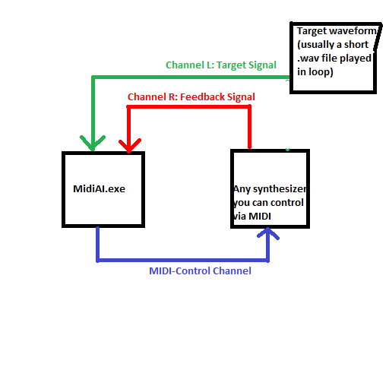

To run the programm make shure that everything's setupt correctly and you can hear your target signal on the left audio channel.

Now run the .exe file!

If everything works properly a window and a console should appear.
Now you can add in addition to the MIDI-notes ten Control Parameters to your synthesizer which are also controlled by the MidiAI.
This is performed by Midi Mapping a Parameter of the Synthesizer. For first control (setup) by the MidiAI just press one of the number keys of your keyboard ("1","2","3"...."0") the MidiAI will send a initial control-MIDI-signal to the currently, for parametrisation prepared synthesizer.

Press Spacebar to start the Programm now !
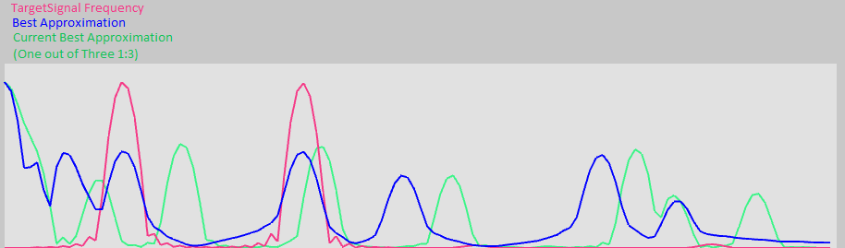
If everything work's properly the program should displaying the frequencys of the signals like this.
Now you should see (and hear) the sinthesizer playing a sequence of notes in regular intervalls.
After some times the MIDI Notes and the MIDI-Control-Output should be tuned for that the sythesizer produces a waveform similar to the target-signal.

Well done ! Just capture the MIDI-output-stream and save it in your DAW/Sythesizer-Presets.

And...

That's it.

